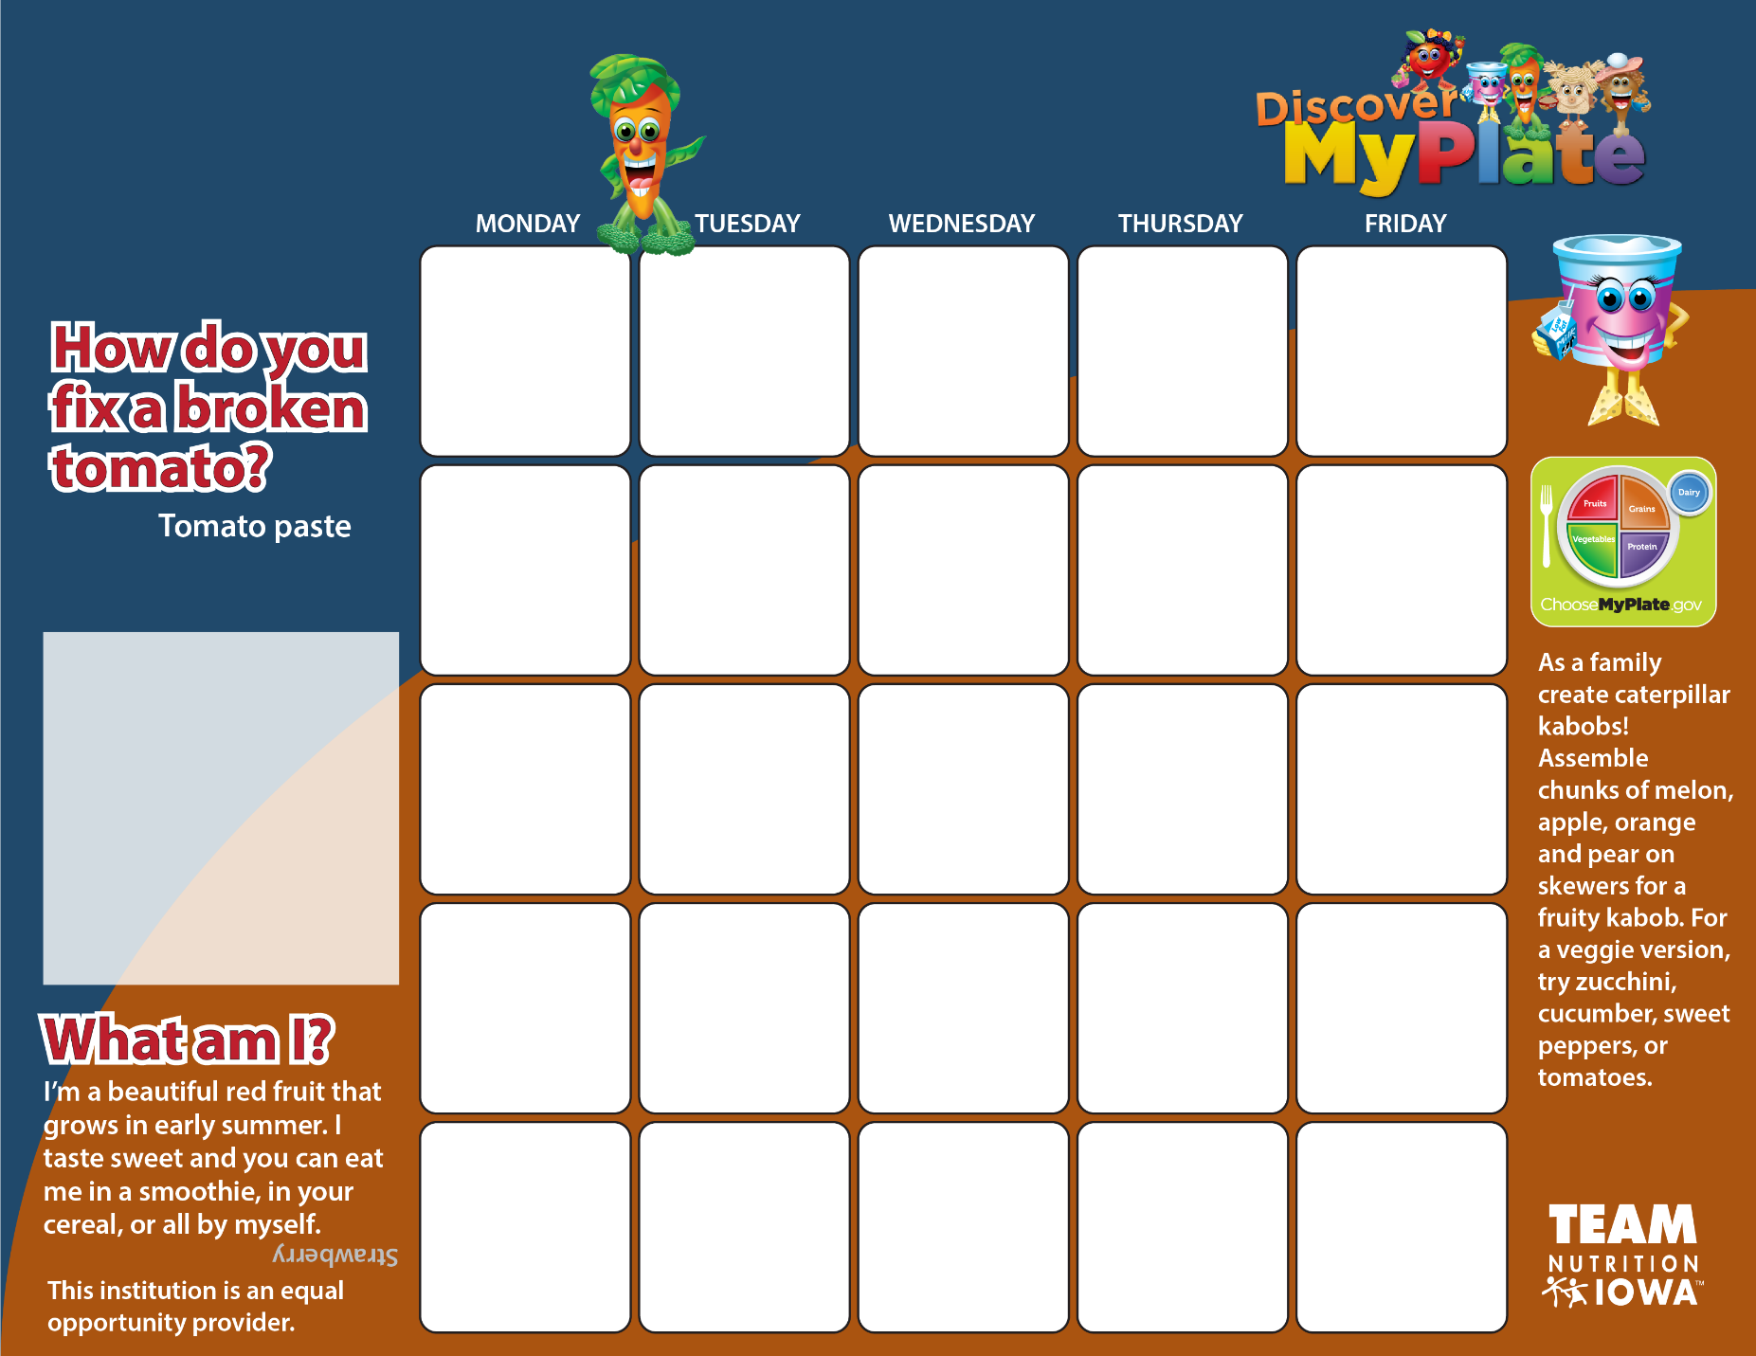

**22**

**Grab & Go**

**Breakfast**

**Fresh Fruit**

**Juice & Milk**

**23**

**Breakfast Pizza**

**Fruit Cup**

**Juice & Milk**

**2**

**Pancake**

**Bites**

**Fruit Cup**

**Juice & Milk**

**1**

**Grab & Go**

**Breakfast**

**Fresh Fruit**

**Juice & Milk**

**24**

**Pancake**

**Bites**

**Fruit Cup**

**Juice & Milk**

**25**

**Breakfast**

**Wrap**

**Fruit Cup**

**Juice & Milk**

**19**

**Breakfast Wrap**

**Fruit Cup**

**Juice & Milk**

**18**

**Biscuit**

**& Gravy**

**Fruit Cup**

**Juice & Milk**

**17**

**Breakfast Pizza**

**Fruit Cup**

**Juice & Milk**

**16**

**Pancake**

**Bites**

**Fruit Cup**

**Juice & Milk**

**15**

**Grab & Go**

**Breakfast**

**Fresh Fruit**

**Juice & Milk**

**8**

**Grab & Go**

**Breakfast**

**Fresh Fruit**

**Juice & Milk**

**9**

**Breakfast Pizza**

**Fruit Cup**

**Juice & Milk**

**10**

**Pancake**

**Bites**

**Fruit Cup**

**Juice & Milk**

**11**

**Breakfast Wrap**

**Fruit Cup**

**Juice & Milk**

**12**

**No School**

**26**

**Biscuit**

**& Gravy**

**Fruit Cup**

**Juice & Milk**

**Nov 2**

**No School**

**Nov 1**

**No School**

**31**

**Breakfast Pizza**

**Fruit Cup**

**Juice & Milk**

**29**

**Grab & Go**

**Breakfast**

**Fresh Fruit**

**Juice & Milk**

**30**

**Pancake**

**Bites**

**Fruit Cup**

**Juice & Milk**

**Special announcement**

**Remember you must pick at least three items from the daily Breakfast menu.**

**Don’t forget one of your choices must be a fruit**

**or**

**fruit juice.**

**Sidney Elementary Breakfast Menu**

**October 2018**

**5**

**Breakfast Wrap**

**Fruit Cup**

**Juice & Milk**

**4**

**Biscuit**

**& Gravy**

**Fruit Cup**

**Juice & Milk**

**3**

**Breakfast Pizza**

**Fruit Cup**

**Juice & Milk**