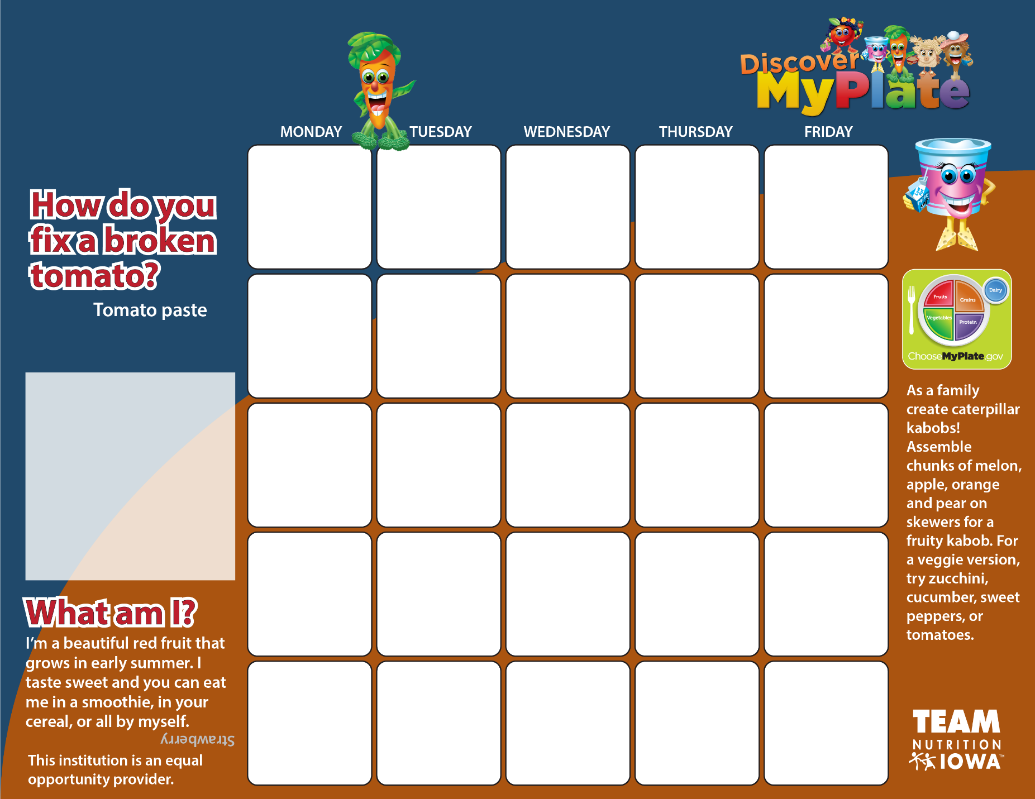

**8**

**Mac & Cheese**

**Seasoned Peas**

**Fresh Broccoli**

**Applesauce Cups**

**Milk**

**9**

**Chicken Egg Rolls**

**Steamed Broccoli**

**Baby Carrots**

**Banana**

**Milk**

**10**

**Pizza**

**Green Beans**

**Tossed Salad**

**Pear Slices**

**Milk**

**11**

**Cheese Quesadilla**

**Corn**

**Lettuce Salad**

**Orange Slices**

**Milk**

**19**

**Turkey & Gravy**

**Mashed Potatoes**

**Apple Slices**

**W/G Roll**

**Milk**

**18**

**Taco Salad**

**Corn**

**Mandarin Oranges**

**Tortilla Chips**

**Milk**

**17**

**Mini Meatball Sub**

**Sweet Potato Fries**

**Fresh Broccoli**

**Peaches**

**Milk**

**16**

**Teriyaki Chicken**

**Brown Rice**

**Baby Carrots**

**Banana**

**Cookie**

**Milk**

**15**

**BBQ Chicken Sandwich**

**Baked Beans**

**Tomato Slices**

**Mixed Fruit**

**Milk**

**26**

**Deli Sub**

**Tri-Tater**

**Lettuce & Tomato**

**Mixed Fruit**

**Milk**

**Nov 2**

**No School**

**Nov 1**

**No School**

**31**

**Cheese Breadsticks**

**Marinara Sauce**

**Green Beans**

**Apple Slices**

**Milk**

**30**

**Chicken Strips**

**Baked Beans**

**Tossed Salad**

**Banana**

**Cookie**

**Milk**

**29**

**Hamburger**

**on a Bun**

**Tater Tots**

**Tomato Slices**

**Peaches**

**Milk**

**25**

**Taco Soup**

**Celery Sticks**

**Apple Slices**

**Tortilla Chips**

**Milk**

**22**

**Pizza**

**Green Beans**

**Tossed Salad**

**Applesauce**

**Milk**

**23**

**Sweet & Sour Chicken Nuggets**

**Brown Rice**

**Baby Carrots**

**Grapes**

**Milk**

**24**

**Chicken Alfredo**

**Steamed Broccoli**

**Tossed Salad**

**Pears**

**Breadstick**

**Milk**

Special announcement

**Remember you must pick at least three items from the daily lunch menu.**

**Don’t forget one of your choices must be a**

**fruit**

**or**

**vegetable.**

**Sidney Elementary Lunch Menu**

**October 2018**

**12**

**No School**

**5**

**Grilled Cheese Sandwich**

**Waffle Fries**

**Fresh Broccoli**

**Mixed Fruit**

**Milk**

**4**

**Beef & Bean Burrito**

**Corn**

**Lettuce Salad**

**Orange Slices**

**Milk**

**3**

**Pasta & Meat Sauce**

**Tossed Side Salad**

**Bread Stick**

**Apple Slices**

**Milk**

**2**

**Chicken Stir Fry**

**Brown Rice**

**Mixed Vegetables**

**Banana**

**Milk**

**1**

**Grilled Chicken Sandwich**

**Baked Beans**

**Baby Carrots**

**Pears**

**Milk**