Sidney Activities Magnet Order Form
Support the National BPA Competitors!
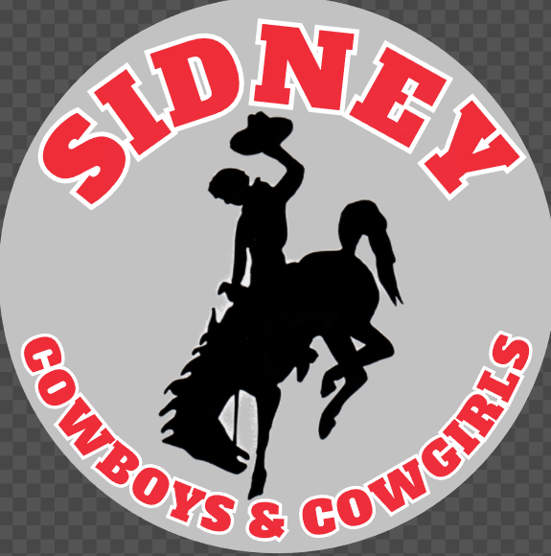
Help send the 7 members of Business Professionals of America to Dallas, TX to compete at the national level! Car magnets designed to support your activity with an opportunity to customize to your favorite student are available for purchase! To view additional examples, please see the school website or Facebook page. Although car-attachment strength, they have versatile uses for the fridge, office use, etc. and perfect for gifts! Please return this order form to the elementary or high school office by April 1, 2022. Payment required at the time of order. Any questions, call or text Dyan Larsen at 402-677-8067. Thank you for your support!

School Spirit Magnet,
5 in. circle

NAME:________________________________ CELL PHONE:_______________________

Deliver to (Circle one): Elementary JH/HS Other:_________________

Customizable options with name and/or jersey number - $10 EACH
ACTIVITY | Volleyball | Football | Basketball | Golf | Softball | Baseball
NUMBER
CUSTOMIZATION - +$2 per magnet - Due to sizing - Limit of 8 characters in name on baseball and softball only) -
_________________________________________________________

Non-customizable - $10 EACH
ACTIVITY | School Spirit | Music | Cross Country | Cheerleading | SWI Wrestling | Track & Field
AMOUNT

TOTAL NUMBER OF ITEMS:____________ TOTAL $ ENCLOSED:__________
(Make checks payable to Sidney Schools)
***If there is not at least 3 purchases of each activity that design may not be ordered***

